Jack Melcher

67574625

EECS 117

HW1 Part1

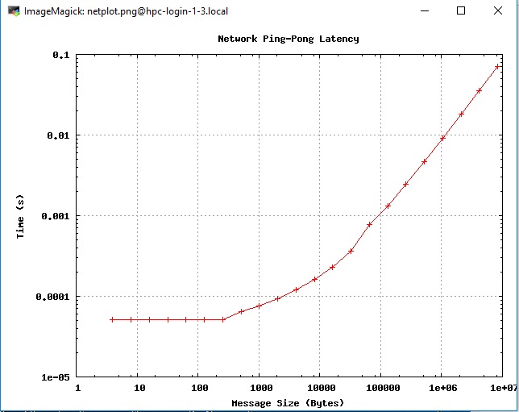

1. Minimum time to send a message of any size is approximately 5e-05 seconds.

2. The slope of the line when message size is large is approximately 1e-08 [s/Bytes]. The slope represents that the time to send a message is proportional to the size of a message.

3.

4. Explanation of pingpong function

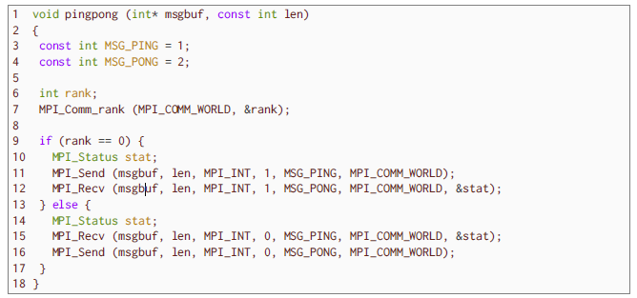

Line 1:

The function definition of pingpong. It has two arguments. The int* msgbuf is a pointer hat references an array that is used as the message buffer. The const int len specifies the length/size of the message buffer array.

Line 3 and 4:

MSG_PING = 1 and MSG_PONG = 2 are tags used during sending and receiving messages

Line 5 and 6:

int rank will be used to store the rank of the node which is determined by MPI_Comm_rank(MPI_COMM_WORLD, &rank)

Line 9 through 17:

If the rank of the node is 0, the node will send a message using MPI_SEND to node of rank 1 using message tag MSG_PING within the group of MPI_COMM_WORLD. Once the message is successfully sent, the node will wait to receive a message using MPI_RECEIVE from node of rank 1 with message tag MSG_PONG within the group of MPI_COMM_WORLD.

If the rank of the node is 1, the node will wait to receive a message using MPI_RECEIVE from node of rank 0 with message tag MSG_PING within the group of MPI_COMM_WORLD. Once the message is successfully received, the node will send a message using MPI_SEND to node of rank 0 using message tag MSG_PONG within the group of MPI_COMM_WORLD.

MPI_Status stat is used when receiving to report status of the communication.